122nd Philippine Civil Service Anniversary (PCSA)
Theme "Transforming Public Service in the Next Decade: Honing Agile and Future-Ready-Servant Heroes”

Philippine Civil Service Anniversary (PCSA) | Date/Period | Venue/Platform | Number of Participants
Online Zumba And Film Showing Fundraising Activity | September 1, 2022 | Reynaldo S. Aquino Socio Cultural Center, NwSSU | 19

Documentations
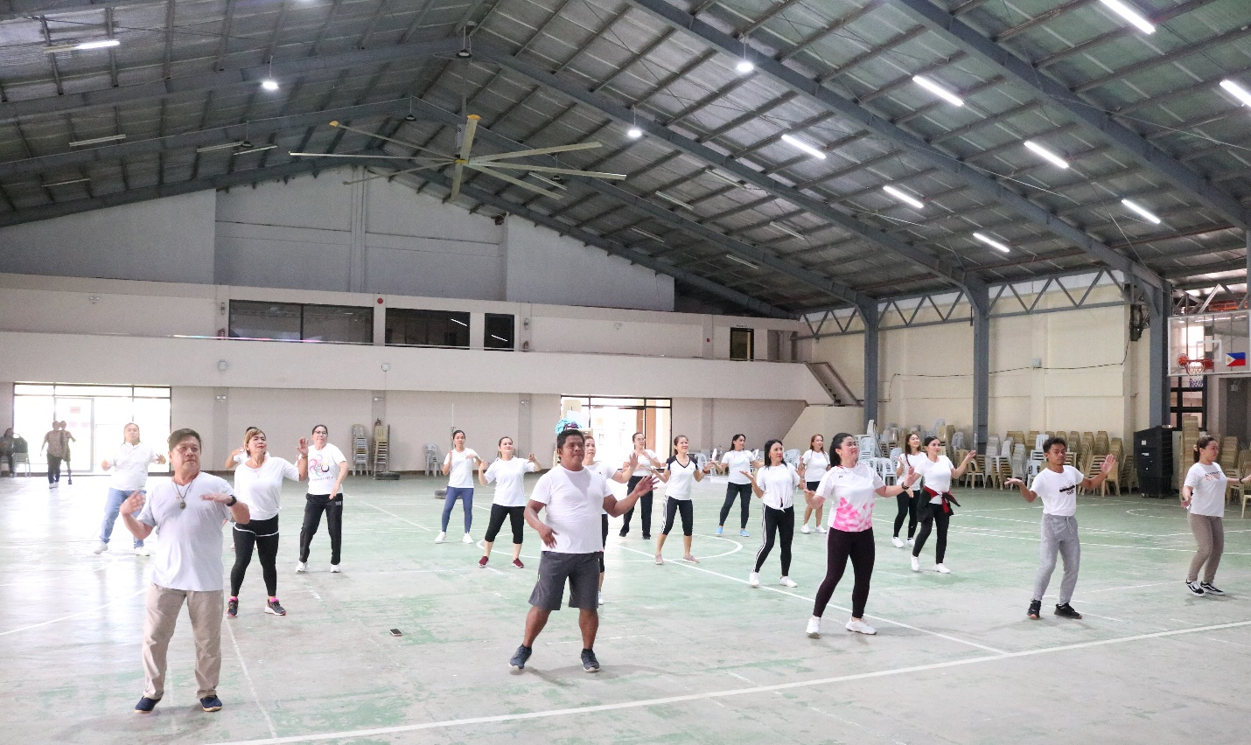

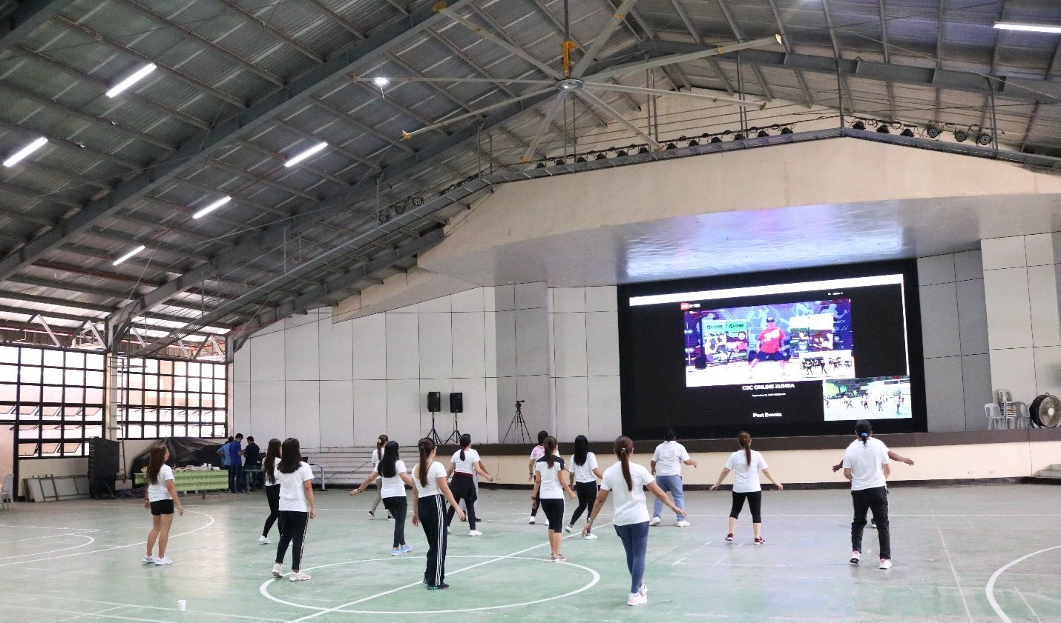

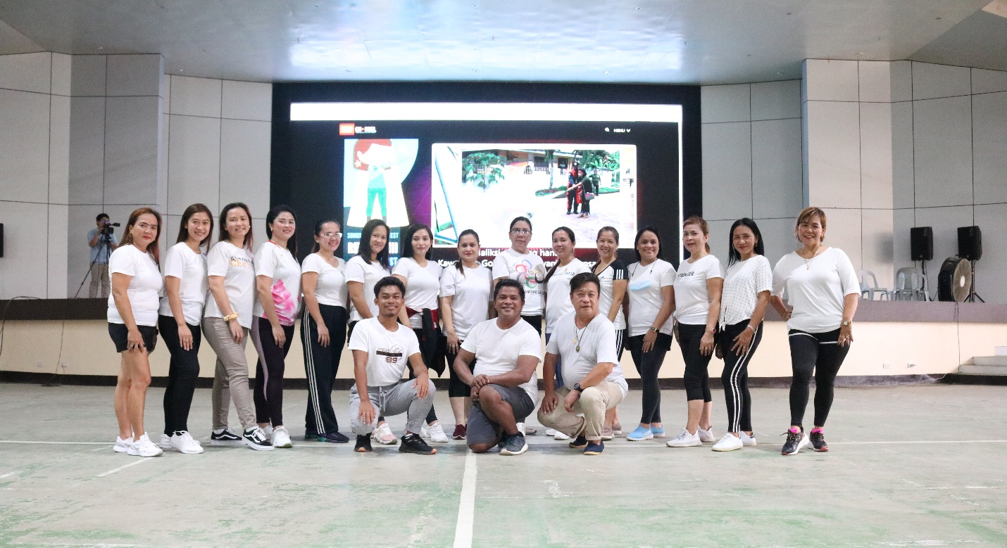

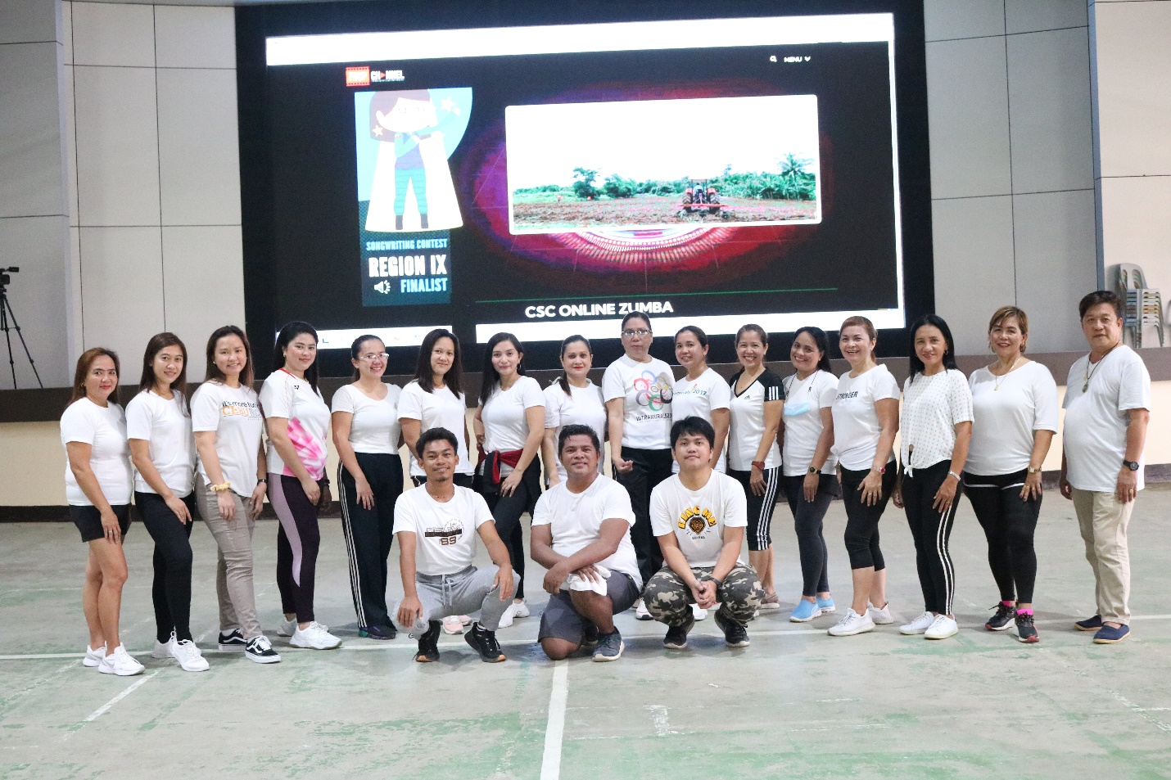

Philippine Civil Service Anniversary (PCSA) | Date/Period | Venue/Platform | Number of Participants
Agency Family Day  Team Building Activity: Bonding Together To Continue To Work With Harmony | September 23, 2022 | Malajog Leisure Park, Brgy. Malajog Tinambacan District, Calbayog City | 223

Documentations

