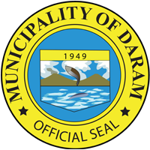
Republic of the Philippines
Province of Samar
MUNICIPALITY OF DARAM

Activity : HOLY MASS AND PARADE IN LINE WITH PCSA 2022 CELEBRATION AND
DARAM FOUNDING ANNIVERSARY
Date : SEPTEMBER 16, 2022
Venue : DARAM, DSAMAR
Number of Pax : ALL MUNICIPAL OFFICIALS AND EMPLOYEES (96)
