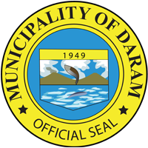
Republic of the Philippines
Province of Samar
MUNICIPALITY OF DARAM

Activity : PALARO NG BAYAN IN LINE WITH PCSA 2022 CELEBRATION AND
DARAM FOUNDING ANNIVERSARY
Date : SEPTEMBER 16-20, 2022
Venue : DARAM, DSAMAR
Number of Pax : ALL MUNICIPAL OFFICIALS AND EMPLOYEES (96)

The activity was participated in by employees from the different offices in the Local Government Unit where they compete in the different games such as Volleyball, Basketball, Badminton and Chess. The activity was a week-long event aims to promote camaraderie and teamwork among them and healthy lifestyle through sports.
