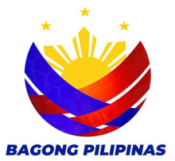
Republic of the Philippines
DEPARTMENT OF PUBLIC WORKS AND HIGHWAYS
LEYTE 3rd DISTRICT ENGINEERING OFFICE
REGIONAL OFFICE VIII
Villaba, Leyte

GROUP WATCHING ACTIVITY DURING THE CONTACT
CENTER NG BAYAN (CCB) PARTNER RECOGNITION PROGRAM
SEPTEMBER 27, 2023, 2:00 PM

