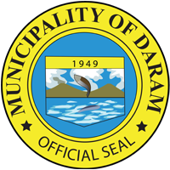
Republic of the Philippines
Province of Samar
MUNICIPALITY OF DARAM

Activity : EMPLOYEES NIGHT AND EXECELLENCE AWARD PCSA 2022 CELEBRATION
AND DARAM FOUNDING ANNIVERSARY
Date : SEPTEMBER 22, 2022
Venue : DARAM, DSAMAR
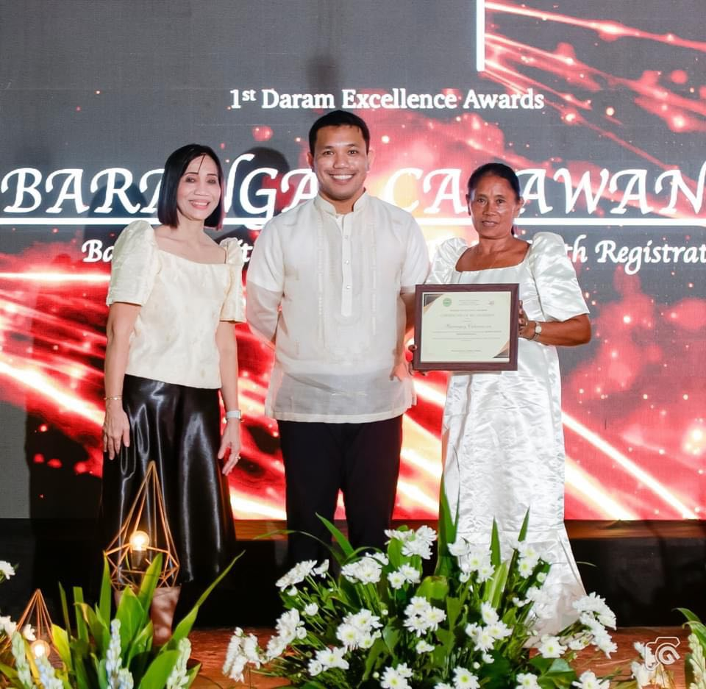
Number of Pax : ALL MUNICIPAL OFFICIALS AND EMPLOYEES (96)
